**Module description**

|  |  |  |  |
| --- | --- | --- | --- |
| Module title | Project integration :  Health care robot | Examination code |  |
|  |  |  |  |
| Phase of study | PP | EC | 8 (224 Hr) |
|  |  |  |  |
| Lecturer | U. Guler/R. Kirmali  J. Stokkink | Document Version | 2019-08-01 |
|  |  |  |  |

This module consists of Three parts:

Project Design of an electronic system (Hardware and Software)

1. board design
2. Software assignment

During the first quarter of the module (e.g. quarter 2.3) 7 hours a week are scheduled for this project. Besides this, more time has to be spend, to make it a total load of 11 hours per week.

During the second quarter of the module (e.g. quarter 2.4) 8 hours a week are scheduled, and an equal time has to be spend besides these hours. So in the second quarter you must spend at least 16 hours a week on this project.

|  |  |
| --- | --- |
| **Quarter 2.3** | **Quarter 2.4** |
|  | Project |
|  | * Scheduled: 8 hrs/wk * Not scheduled: 8 hrs/week |
| Project   * Scheduled: 7 hrs/wk * Not scheduled: 3 hrs/week |  |
| PCB design (3)  Software (3) |  |

To get your final mark all separate marks must at least be sufficient (>= 5.5) and the Assignments, the Microcontroller board and the software must be a pass.

|  |  |  |  |  |
| --- | --- | --- | --- | --- |
| **Assessment** | **Who** | **By** | **Result** | **Weighing** |
| Project | Group/Individual | Lecturer | Mark | 70% |
|  |  |  |  |
| Microcontroller board (EIE)  Software (TI/ACS) | Individual | Lecturer | 10  10 | 30%  30% |
| Presentation/Demonstration | Individual | Lecturer | Pass/ No pass | Pass |

# Project – Design of an Electronic system (Health care robot)

## Introduction

The goal of this project is the designing and building of a Health care robot. Several aspects of your study have to be integrated in this project. A basic knowledge from following modules is required:

Programming 1/2

Microcontrollers 1

Design and Realization

Basic knowledge has to be applied and if appropriate new knowledge has to be independently learned.

The design has to be done using a methodology, namely the V-model. Designing according to the model and delivering intermediate documents is an essential goal of the project. As far as possible work will be done according to the Scrum agile work method!

## Competences and learning goals

Competences

The competences required for this project are the eight competences of a Bachelor of Engineering, see table below. After completing this project, the student has each of the competences at level 1.

|  |  |  |  |
| --- | --- | --- | --- |
|  | **Competence** | **Level (*)** |  |
| 1 | Analyse | 1 | - Translation of user requirements into a methodological approach  - Analysis for the Design Requirements  - Analysis for the Functional Design and motivation of choices  - Analysis for the Technical Design and motivation of choices |
| 2 | Design/Engineer | 1 | Technical execution of the project |
| 3 | Realise | 1 | Building of the system (usable for a demonstration) |
| 4 | Control | 1 | Verification and Validation of the system  (Testing and part of the report) |
| 5 | Manage | 1 | - Management during the execution of the project  (following the methodological approach in the PP)  - Modification of the PP according to changing situations |
| 6 | Advise | 1 | - Recommendations for future development (part of the report) |
| 7 | Research | 1 | - Research and analysis for the Design Requirements  - Research for the Functional Design and motivation of choices  - Research for the Technical Design and motivation of choices |
| 8 | Professionalise | 1 | - Communication  - Collaboration  - Attitude  - Presentation |

(*) Level 1 Nature of the assignment: basic, structured, applying a standard methodology

Nature of the context: known, basic, mono discipline, at the university

Amount of independency: limited, controlled guidance

Learning goals:

* Hardware design. microcontroller software
* Integration of theory and practical skills from the BOKs (Body Of Knowledge and Skills)
* Designing a small system using a methodological method (V-model)
* Writing intermediate documents such as a Project Plan, Design Requirements and Functional Design
* Independently learning something new

## Prerequisites

|  |  |  |
| --- | --- | --- |
| **Module** | **Quarter** | **Topic** |
| Programming 1/2 | 1.1 | Arduino programming (All topics) |
|  |  |  |
| Software engineering | 2.1 | all topics (TI) |
| Digital signal Processing | 2.3 | Moving average filter |
| Electrom. Comp. | 2.1 | PCB design |
| Project simulation and realization | 2.2 | All topics |

## Literature project

| **Title** | **Author** | **Publisher** | **ISBN - Availability** |
| --- | --- | --- | --- |
| Project management | Roel Grit | Noordhof Uitgevers | NL : 978-90-01-79093-6  E : 978-90-01-79092-9 |
| Project Based and Methodological Design 1.5.1 | J.W. van Dijk | Saxion | Blackboard |

## Software

| **Title** | **Publisher** | **Availability** |
| --- | --- | --- |
|  |  |  |
| Arduino software for ESP32 | ATMEL | Internet |
| Micro python software ESP32 (ACS.TI students) |  | Internet |
| PCB design  Multisim and Ultiboard software |  |  |
| GanttProject | GanttProject Team | Internet |

## Project Assessment

The assessment of the project is based on 6 different topics with weighing factors, see table below. More detailed information on the assessed topics (i.e. sub-topics) can be found in the assessment form. A Project mark will only be calculated if the Project Plan is a pass, and mark1 and mark2 are at least sufficient (≧5.5).

|  |  |  |  |  |  |  |  |  |  |  |  |
| --- | --- | --- | --- | --- | --- | --- | --- | --- | --- | --- | --- |
| **Assessment** | **Analyse** | **Design/Engineer** | **Realise** | **Control** | **Manage** | **Advise** | **Research** | **Professionalise** | **Who** | **Result** | **Weighing** |
| Project Plan | x |  |  |  | x |  |  |  | Group | Pass/no Pass | pass |
| Technical Functioning | x | x | x |  |  |  | x |  | Individual | Mark 1 | 20% |
| Professional Functioning |  |  |  |  | x |  |  | x | Individual | Mark 2 | 20% |
| Result |  |  |  | x |  |  |  |  | Group | Mark3 | 30% |
| Reports | x | x |  |  |  | x | x | x | Group | Pass/no Pass | pass |
|  |  |  |  |  |  |  |  |  |  |  |  |
| Microcontroller board (Q1)(EIE)  Software (Q1)(TI/ACS) |  |  |  |  |  |  |  |  |  | Mark4 | 30% |

(*) Each project group has to give a demonstration inweek4.6. All students have to deliver a part of the presentation. The mark for the presentations will be based on the structure/slides/contents of the presentation (group responsibility) and not on the presentation skills (individual).

The ‘Project mark’ can be calculated as follows:

*Project mark = 0.2*mark1 + 0.2*mark2 + 0.3*mark3 + 0.3*mark4*

Retake

If the project is not finished in week 4.8, there will be a retake in week 4.11. In case of a retake, the mark for the project will be calculated as follows:

*Project mark = (5.5 + 0.2*mark1 + 0.2*mark2 + 0.3*mark3 + 0.3*mark4)/2*

If the result is still insufficient after the retake, the student(s) has to participate next study year in a new project.

## Week planning project

| **week** | **Hours** | | **Special activity** | **Deliverable** |
| --- | --- | --- | --- | --- |
| **Scheduled** | **Not scheduled** |
| 3.1 | 8 | 3 | Introduction V-model  Introduction Project Plan  Introduction PCB assignment  Introduction Software assignment  Introduction research |  |
| 3.2 | 8 | 3 | Project meeting  Introduction research  Lecture about PCB design.(ELT) | Project Plan  Circuit design (ELT) |
| 3.3 | 8 | 3 | Introduction Design Requirements  Project meeting  Introduction research | introduction research |
| 3.4 | 8 | 3 | Project meeting  Introduction research | Design Requirements |
| 3.5 | 8 | 3 | Introduction Functional Design  Project meeting  Introduction research |  |
| 3.6 | 8 | 3 | Project meeting/demonstration  Introduction research 2 | Functional Design  Pcb design (ELT)  Research report (ACS/TI) |
| 3.7 | 8 | 3 | Project meeting  Introduction Technical Design | Assessment: introduction research |
| 3.8 | 8 | 4 | Technical Design |  |
| 3.9 |  |  |  | Technical Design |
| 3.10 |  |  |  | Retake Assessment introduction research1 |
| 4.1 | 8 | 8 | Project meeting |  |
| 4.2 | 6 | 6 | Project meeting |  |
| 4.3 | 6 | 6 | Project meeting |  |
| 4.4 | 6 | 6 | Project meeting |  |
| 4.5 | 6 | 6 | Project meeting |  |
| 4.6 | 7 | 8 | Project meeting | Final Report  (Realisation, Test, Conclusions) |
| 4.7 | 8 | 8 | Demonstration/Assessment |  |
| 4.8 | 8 | 8 |  |  |
| 4.9 |  |  | **Retake** | **Retake** |
| 4.10 |  |  |  |  |
| 4.11 |  |  |  |  |

# Introduction Research

## Description

For EIE students, knowledge of microcontroller pcb design is a must. The only way to get this knowledge is to do it.

For ACS/TI students,knowledge of Python and modern microcontroller rsystems is a must

## Course objectives

The student has basic knowledge and practical experience in setting up a microcontroller PCB design(EIE) and programming modern microcontroller (TI/ACS).

## Requirements

### PCB board design:

* ESP 32 module
* Analogue input.
* Analogue circuit
* Digital inputs (Switches)
* Digital I2C or SPI
* PCB Design

### C-programming (Or Phyton)

* ESP 32 module
* I2c or SPI
* Analogue input.
* ESP 32 subject , like BT or WIFI…

# Project Healthcare Robot

## Description

A group of student shall work together on the design and realisation of a Healthcare Robot

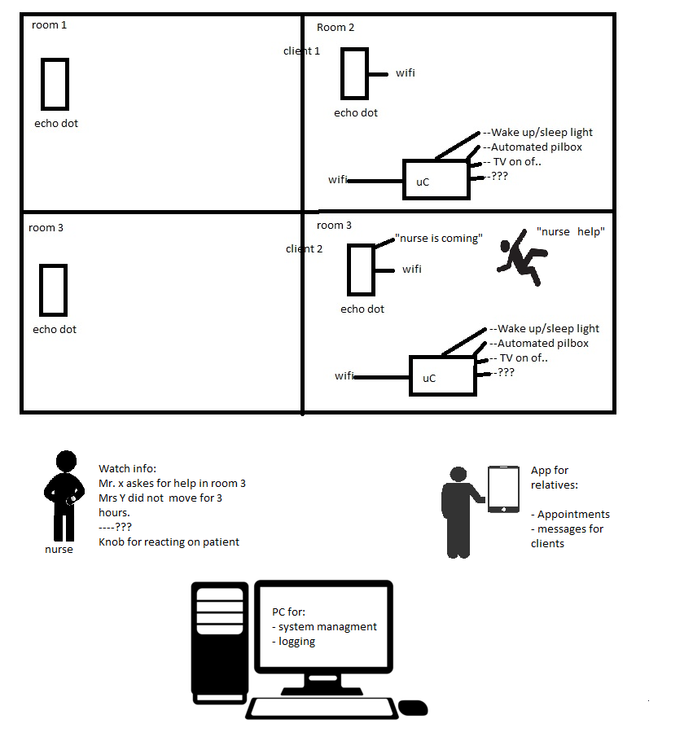

## Course objectives

The students have basic knowledge and practical experience to design electronic equipment and PC software, in a group.

## Requirements

The minimal requirements: (also see introduction slides)

The system must

* Must have an emergency help function in all rooms .
* Show a nurse on a wearable device where the help is needed.
* Logging the events
* Give notes to the client about his day schedule. (Medicines uses, visits etc..) (on alexa or google home)

One of the main objectives is to get a good requirements list. In discussion with the client (Teachers).

## Assessment

A demonstration has to be given of the result

|  |  |  |  |  |
| --- | --- | --- | --- | --- |
| **Assessment** | **Who** | **By** | **Result** | **Weighing** |
| Demonstration of the realisation (PCB or C-code/Phyton) | Group. Each of the members must do a part of the demonstration | Lecturers |  | 30% |